**­­­­User Guide:**

**Linkage Priority Tool of the Linkage Mapper Toolbox**

*Version 2.0—Updated December 2017*

John A. Gallo1 and Randal Greene2

1Conservation Biology Institute

2Feaver’s Lane

**Software Requirements and Licensing**

Linkage Priority tool requires **ArcGIS 10** with the Spatial Analyst extension (we have tested with versions up to 10.4.1). More details can be found on the Linkage Mapper website, where our code is hosted: <http://www.circuitscape.org/linkagemapper>.

**Preferred Citation**

Gallo, J. A., & R. Greene. 2017. User Guide: Linkage Priority Tool of the Linkage Mapper Toolbox. Figshare. <https://doi.org/10.6084/m9.figshare.5673715>

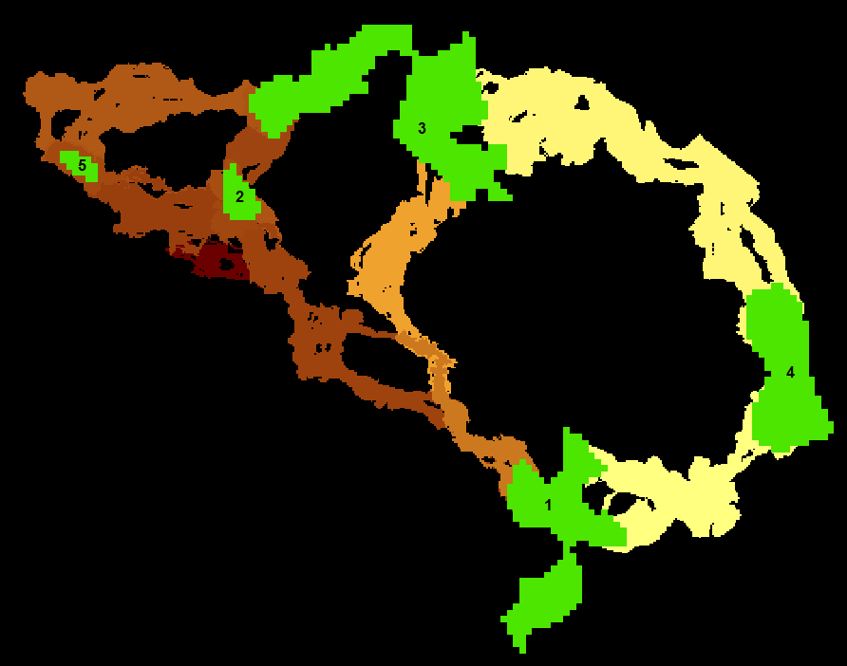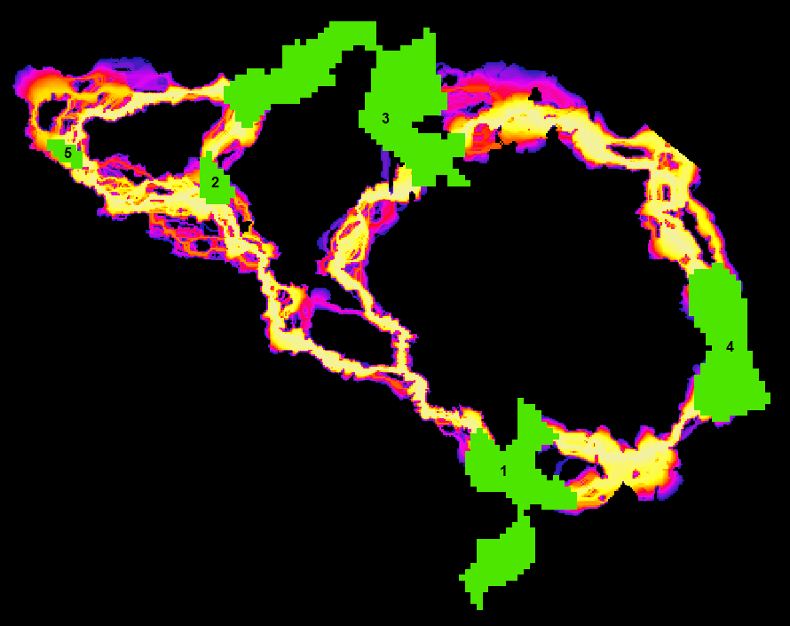

**Table of Contents**

1 Introduction 3

2 Acknowledgements 3

3 Installation 3

4 Using Linkage Priority 4

4.1 Required Inputs 6

4.2 Core Area Value (CAV) Options 6

4.3 Corridor Specific Priority (CSP) Options 6

4.4 Blended Priority Options 7

4.5 Additional Options 7

4.6 Advanced Settings in lp_settings.py 7

5 Geoprocessing Overview 8

6 Other Usage Notes 11

6.1 Upgrading 11

6.2 Enhancing Analyses Using Optional Settings 11

6.3 Advanced Fine Tuning: Making Linkage Mapper and Linkage Priority Outputs have similar extents. 12

6.4 Other Suggestions and Troubleshooting 13

7 Support 13

8 Key Acronyms 14

9 Linkage Priority Tutorial 14

9.1 Run with Default Parameters 14

9.2 Add Climate Refugia 17

9.3 Add Climate Signature 19

10 Advanced Linkage Priority Tutorial 21

10.1 Shortcut for Multiple Runs 21

10.2 Add Centrality 22

10.3 Inspect Core Area Value Component Calculations 23

# Introduction

Linkage Priority (LP) is an ArcGIS tool that helps quantify the conservation priority of each linkage in a landscape. This output is combined with the output of Linkage Mapper (LM), from a previous step, to show a blended priority output. There are five criteria that combine in a weighted sum to determine the relative priority of each linkage. An example criterion is the relative permeability of a linkage (i.e. the mean resistance values along the least cost path). One of the criteria, the relative core area values of the two cores being connected, is composed of five sub-criteria combined in a weighted sum. See “Using Linkage Priority” for more details.

LP came about primarily to facilitate embedding of linkage analysis in iterative geoprocessing routines such as Land Advisor models. Land Advisor evaluates a landscape for conservation priorities, uses a greedy heuristic to assume the highest priority area is conserved, and then repeats the process to identify the second-highest priority area. Embedding LM/LP allows Land Advisor to extend its scope from prioritization of core protected areas to include prioritization of corridors among them. LP can also be used in standalone corridor identification projects that require prioritization of conservation action among potential corridor areas.

# Acknowledgements

We initiated this work with funding from a South Africa National Research Foundation post-doctoral research grant (#47264) through Nelson Mandela Metropolitan University. In 2014 we approached Brad McRae with the idea of embedding the Linkage Priority algorithm into Linkage Mapper and he was very gracious, and encouraging. The result here is a change of the original algorithm to allow this merge.

Alas, Brad has since passed away, stricken by cancer. “Everyone who knew Brad was impressed with his intelligence, thoughtfulness, integrity, honesty, and his steadfast commitment to what he cared about: his family, friends and conserving the natural world.”[1] We couldn’t agree more. He asked Dr. Gallo to carry the Linkage Mapper project forward and we are honored to do so with some support from Conservation Biology Institute, and hopefully much support from the Linkage Mapper community. Rest his soul.

We would like to thank the additional organizations that have funded this work: Sonoma County Agricultural Preservation and Open Space District, The Wilderness Society, and Conservation Biology Institute.

Thanks also to Darren Kavanagh, Annie Prisbrey, and Tim Sheehan for their advice and their participation in the release of LP.

# Installation

Download Linkage Mapper from <http://www.circuitscape.org/linkagemapper> and follow the installation instructions in section 2 of the Linkage Mapper User Guide. Starting at version 2.0.0, LP is included with LM.

You can test your installation by running the tutorial at the end of this document.

# Using Linkage Priority

The key components of LP’s multi-criteria analysis are as follows:

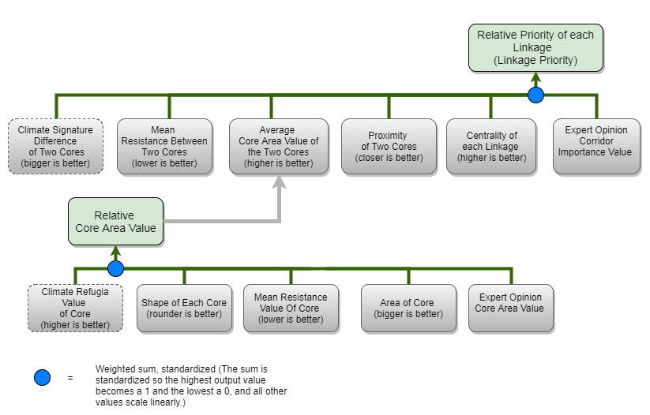

The weights for these, and the associated parameters, are accessed through the graphical user interface (GUI).

LP is run after understanding and running LM, and optionally after Centrality Mapper. Open LP from the Linkage Mapper Toolkit.

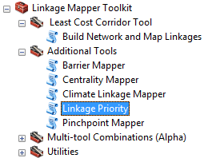

The following tool dialog should appear:

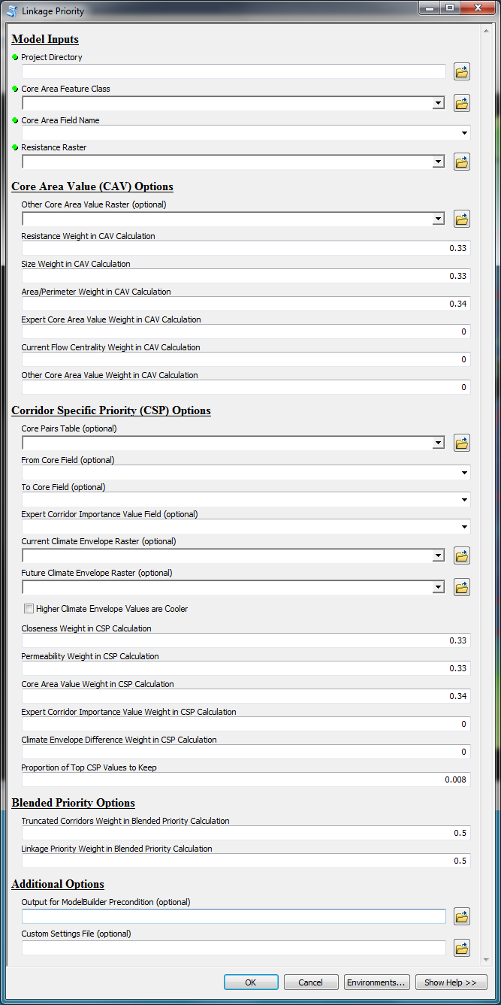

Descriptions for the required and optional tool parameters follow. They are also available in the tool dialog by selecting a parameter and clicking Show Help >>, for example:

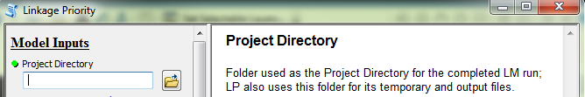

For additional details, please see the Geoprocessing Overview and Other Usage Notes sections later in this document.

## Required Inputs

* *Project Directory*: folder used as the Project Directory for the completed LM run; LP also uses this folder for its temporary and output files
* *Core Area Feature Class*: core habitat area polygons, used as the Core Area Feature Class for the completed LM run
* *Core Area Field Name*: field in the Core Area Feature Class containing a unique identifier for each core, used as the Core Area Field Name for the completed LM run
* *Resistance Raster*: cost raster, used as the Resistance Raster for the completed LM run

## Core Area Value (CAV) Options

* *Other Core Area Value (OCAV) Raster*: optional raster whose values within each core will be averaged to create the OCAV for that core
* Weighted sum weights (should sum to 1) to be used in the calculation of the CAV attribute:
  + *Resistance Weight*: decimal value between 0 and 1 to be multiplied by the normalized mean resistance for the core
  + *Size Weight*: decimal value between 0 and 1 to be multiplied by the normalized size of the core
  + *Area/Perimeter Weight*: decimal value between 0 and 1 to be multiplied by the normalized area/perimeter ratio of the core
  + *Expert Core Area Value (ECAV) Weight*: decimal value between 0 and 1 to be applied to the normalized optional ecav field, for storing an expert assessment of the relative value of each core; see sections 6.2 and 6.4 below for additional details
  + *Current Flow Centrality (CFC) Weight*: decimal value between 0 and 1 to be applied to the normalized CF_Central field, which is optionally calculated by Centrality Mapper after running LM but before running LP; see section 6.2 below for additional details
  + *Other Core Area Value (OCAV) Weight*: decimal value between 0 and 1 to be applied to the normalized ocav field, which is calculated from the optional OCAV raster; see section 6.2 below for additional details

## Corridor Specific Priority (CSP) Options

* *Core Pairs Table*: optional table, feature class or raster attribute table containing an Expert Corridor Importance Value (ECIV) field that stores an expert assessment of the relative value of each corridor
* *From Core Field*: field in the Core Pairs Table that stores the unique identifier for one of the cores in the pair
* *To Core Field*: field in the Core Pairs Table that stores the unique identifier for the other core in the pair
* *Expert Corridor Importance Value Field*: field in the Core Pairs table that stores the expert assessment of the corridors
* *Current Climate Envelope Raster*: optional raster used to calculate the current climate envelope for each core, which feeds into the climate envelope difference calculation for the two cores at the end of each corridor; see section 6.2 below for additional details
* *Future Climate Envelope Raster*: optional raster used to calculate the future climate envelope for each core, which feeds into the climate envelope difference calculation for the two cores at the end of each corridor; see section 6.2 below for additional details
* *Higher Climate Envelope Values are Cooler*: normally, higher climate envelope values indicate warmer/drier; check this option to indicate that higher climate envelope values are cooler/wetter
* CSP weighted sum weights (should sum to 1) used to create a CSP raster for each corridor:
  + *Closeness Weight*: decimal value between 0 and 1 to be multiplied by the normalized distance between the two cores of the corridor
  + *Permeability Weight*: decimal value between 0 and 1 to be multiplied by the normalized permeability (inverse of the average resistance) of the corridor
  + *Core Area Value Weight*: decimal value between 0 and 1 to be multiplied by the normalized average CAV of the two cores of the corridor
  + *Expert Corridor Importance Value Weight*: decimal value between 0 and 1 to be multiplied by the normalized ECIV of the corridor
  + *Climate Envelope Difference Weight*: decimal value between 0 and 1 to be multiplied by the normalized climate envelope difference between the two cores of the corridor
* *Proportion of Top CSP Values to Keep*: decimal value between 0 and 1 that is used to clip the size of each corridor before they are combined into the project_CPV and project_linkage_priority output rasters

## Blended Priority Options

* Blended Priority weighted sum weights (should sum to 1) used to create the project_blended_priority output raster:
  + *Truncated Corridors Weight*: weight to be multiplied by the project_NORMTRUNC output raster
  + *Linkage Priority Weight*: weight to be multiplied by the project_linkage_priority raster

## Additional Options

* *Output for ModelBuilder Precondition*: optional output copy of the input cores, which can be used in ModelBuilder workflows to indicate that LP has finished processing
* *Custom Settings File*: optional .py file to be used in place of lp_settings.py, which facilitates keeping all the settings needed to reproduce a scenario run

## Advanced Settings in lp_settings.py

The following settings will not normally need to be changed, and can only be changed by editing lp_settings.py:

* RELPERMNORMETH (number): relative permeability normalization method (use 0 for score range normalization; any other value for maximum value normalization)
* RELCLOSENORMETH (number): relative closeness value normalization method (use 0 for score range normalization; any other value for maximum value normalization)
* CALCLP (Boolean): calculate linkage priority
* NORMCORRNORMETH (number): normalized corridor normalization method (use 0 for score range normalization; any other value for maximum value normalization)
* RESNORMETH (number): resistance normalization method (use 0 for score range normalization; any other value for maximum value normalization)
* SIZENORMETH (number): size normalization method (use 0 for score range normalization; any other value for maximum value normalization)
* APNORMETH (number): area/perimeter ratio normalization method (use 0 for score range normalization; any other value for maximum value normalization)
* ECAVNORMETH (number): ecav normalization method (use 0 for score range normalization; any other value for maximum value normalization)
* CFCNORMETH (number): cfc normalization method (use 0 for score range normalization; any other value for maximum value normalization)
* **MINCPV (number): minimum corridor priority value (use 0 to keep all). Best to examine CPV values from a previous run in setting a non-zero value.**
* NORMALIZERCI (Boolean): normalize RCI
* TRUNCNORMETH (number): truncated raster normalization method (use 0 for score range normalization; any other value for maximum value normalization)
* CALCBP (Boolean): calculate blended priority (requires CALCLP above to also be True)
* NORMALIZELP (Boolean): normalize Linkage Priority
* NORMALIZEBP (Boolean): normalize Blended Priority
* KEEPINTERMEDIATE (Boolean): keep intermediate outputs for troubleshooting purposes
* MAXCSPWEIGHT (Boolean): relative max CSP value weight in CPV calculation
* MEANCSPWEIGHT (Boolean): relative mean CSP value weight in CPV calculation

# Geoprocessing Overview

The following algorithm details are not required for using LP. If, however, you would like to understand the algorithm further, a high-level overview is provided here (additional details are available in the Linkage Priority Developer Documentation).

* Check that LM in the same Project Directory successfully finished Steps 3 and 5, and terminate if issues

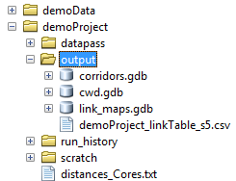

* Make preliminary calculations for each corridor

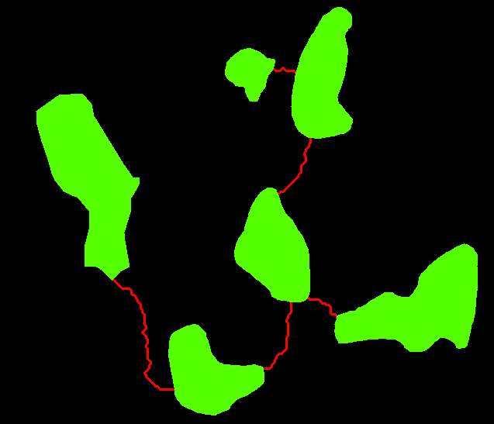

* + Calculate Permeability
  + Calculate Relative Closeness

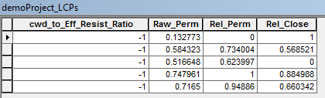

* + Invert and normalize

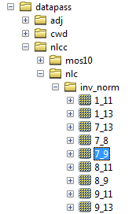

(set KEEPINTERMEDIATE = True in lp_settings.py to see these datsets)

* Calculate Core Area Value (CAV) and its components for each core
  + Check weights and warn if issues

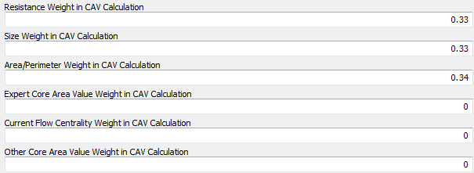

* + Add and calculate attributes in the input Core Area Feature Class

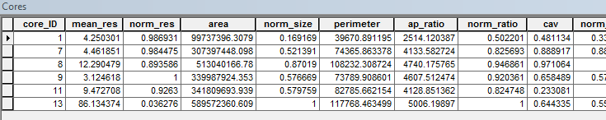

* [Optional] Calculate climate envelope attributes for each core
* Complete calculations for each corridor
  + [Optional] Add and calculate attributes of the Core Pairs table
  + Calculate corridor specific priority (CSP) raster for each corridor

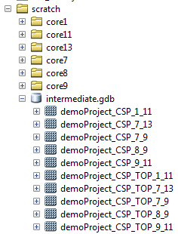

(set KEEPINTERMEDIATE = True in lp_settings.py to see these datsets)

* Create overall result rasters

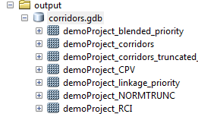

* + Combine CSP_TOP rasters using Max and Mean to create overall Corridor Priority Value (project_CPV) raster
  + Clip project_CPV to the MINCPV and normalize to create relative corridor importance (project_RCI) raster
  + Clip project_RCI to extent of truncated raster to create project_linkage_priority raster
  + Invert and normalize truncated raster to create project_NORMTRUNC raster
  + Calculate overall project_blended_priority raster

# Other Usage Notes

## Upgrading

For those upgrading to version 2.0.0 from earlier versions of LM, please consider the following:

* If you want your old projects to automatically use the new LM and LP, install the toolbox in the same location as the previous version.
* Due to the addition of new LM parameters in the LM tool dialog, running LM from geoprocessing results history will result in “ERROR 000820 The parameters need repair”. To overcome this issue, run LM from the toolbox, not from the geoprocessing history.
* ModelBuilder models that use LM will need to be edited, re-validated and saved.

## Enhancing Analyses Using Optional Settings

LP’s optional settings can be used in a variety of ways. Some suggestions are provided here:

* Climate change analyses can be incorporated into linkage prioritization in at least two ways:
  + By providing an Other Core Area Value raster, such as a refugia dataset, that reflects the relative importance of different areas of the landscape in providing resilience to climate change. This will impact the Core Area Value, which is a component of Corridor Priority Value. See the Linkage Priority Tutorial below for an example.
  + By providing Current, and optionally Future, Climate Envelope datasets, which allow a Climate Envelope Difference to be calculated for each corridor. See the Linkage Priority Tutorial below for an example.
* Expert input can be incorporated in at least two ways:
  + By adding an Expert Core Area Value field (must be name “ecav”) to the Cores polygon input dataset. This will impact the Core Area Value, which is a component of Corridor Priority Value.
  + By providing a table of core pairs, with an Expert Corridor Importance Value (ECIV) field (can be any name). ECIV is an optional component of Corridor Priority Value.
* Centrality is a measure of how important a link or core area is for keeping the overall network connected. If run, Centrality Mapper will create a field in the Cores polygon dataset called CF_Central. Providing a Current Flow Centrality Weight will normalize CF_Central and include it in the Core Area Value calculation.

## Advanced Fine Tuning: Making Linkage Mapper and Linkage Priority Outputs have similar extents.

The width of the linkages from LP are different then those from LM. When these two sets of linkages are overlaid to get the “blended priority” output, (or in external post processing), the minimum extent of each linkage from the two products is used. For best results[2], it is best if the LP linkage widths are similar to those derived from LM.

The width of LP linkages are affected most dominantly by the setting “Proportion of Top CSP Values to Keep” (PropKeep). A deliberate way to set this value so the outputs best match those from LM is as follows:

* Run an initial run of LM and LP.
* Label the cores layer in ArcMap with a Core ID# and then add the following layers
  + The LM output: \outputs\corridors.gdb\(projectname)_corridors_truncated_at_(X
  + a “CSP” layer: \scratch\intermediate.gdb\(projectname)_CSP_(Core#A)_(Core#B).
    - The KeepIntermediate parameter in the lm_Settings.py file must = True for these files to be available.
    - It is useful to add one where the “carryover effect” is most apparent on the LP output (see footnote).
* Adjust the Min/Max color ramp of the “CSP” layer (using the Properties/symbology tab) with a few trial and error tests until it aligns sufficiently with the LM output.
  + Hint: Min value will likely be very near the Max value.
    - See “if you want to understand the algorithm more” below for an alternate way of approaching this task.
* Once this point is reached, the new PropCSP value for the next run can be calculated using this formula: (max-newmin)/(max-oldmin); where newmin is the new min value that yields the desired output and oldmin is the original min value.
* Apply this result as the PropCSP value for the next model run.

Advanced nuances to the above:

* It is best to NOT use the Bounding Circles Buffer Distance of LM when using LP. Using this makes increased variance in the widths of the linkages resulting from Proportion of Top CSP Values to Keep. Two cores that are small and close together will have a much smaller range of values than large/far cores.
* Extent of analysis also affects this relationship between LM linkage width and LP linkage width. If calibrating the model with test runs, it is best to use the entire extent, but just use 4 or so cores, rather than using a sub-region for calibration.
* Now that LP exists, some of the techniques in LM for eliminating linkages are not as necessary, and could be left unused. LM provides the following options for limiting the number of linkages mapped: Maximum Cost-Weighted Corridor Distance and Maximum Euclidean Corridor Distance. LP users may want to consider relaxing or eliminating these constraints in order to allow long, but high quality linkages to still be mapped. The long linkages that do not make ecological sense will get a very low RCI value. (These can be removed using MinCPV value in LP). More importantly, the ones that do make sense will still be mapped. A tradeoff is that not using these options will increase LM’s runtime.
* Due to rounding errors, it may be that all the above works better with resistance surfaces that have a high range of values, such a 1-1000, but that still needs to be confirmed.

If you want to understand the algorithm a bit more:

* Scale \(projectname)_CSP_(Core#A)_(Core#B) using a Min/Max color ramp (using the symbology tab) to the same ratio as Proportion of Top CSP Values to Keep (PropCSP) in run that created it.
  + This can be done using the formula max-[(max-min)*PropCSP], using the max and min values of the raster.
  + Manually apply this value as the new min value in the symbology tab
    - This should match the output for this linkage on the corridors.gdb\(projectname)_linkage_priority raster.
    - As well as the intermediate.gdb\(projectname)_CSP_TOP_(Core#A)_(Core#B)

## Other Suggestions and Troubleshooting

* When creating a field to store expert values for ECIV for each corridor, project_LCPs is not a good place to do this because it gets overwritten on every run of the LM tools. One option is to make a copy of this feature class in another location and use it.
* If you encounter an error along the lines of “ERROR 010423: project_RCI.RASTER.1(Band_1) does not have valid statistics as required by the operation” when calculating overall linkage priority, it could be that the setting used for Proportion of Top CSP Values to Keep resulted in an empty Corridor Specific Priority for one or more corridors, and therefore an empty RCI raster. Try a larger value for the Proportion of Top CSP Values to Keep setting.
* If you move the project directory structure and files to another location after LM has been run (not advised), please note that:
  + LM must be re-run before LP can be run, because the LM environment has been picked up from the run history and contains the old path.
  + You cannot re-run the LM family of tools from the geoprocessing history because the location of the tools will have changed.

# Support

Please join the Linkage Mapper User Group to get updates, report bugs, and suggest enhancements (<https://groups.google.com/forum/#!forum/linkage-mapper>).

We also encourage contributions to the LM project by ArcGIS/Python developers. This could include enhancements and fixes to existing tools, and development of new tools for the LM toolbox. We encourage new tools to follow the protocols in Linkage Priority and Climate Linkage Mapper, which are currently the two newest tools in the LM toolbox. Please see the LP Developer Documentation for details on the source code repository.

# Key Acronyms

* CAV = Core Area Value
* CFC = Current Flow Centrality
* CPV = Corridor Priority Value
* CSP = Corridor Specific Priority
* CW = Cost Weighted
* CWD = Cost Weighted Distance
* ECAV = Expert Core Area Value
* ECIV = Expert Corridor Importance Value
* LCP = Least Cost Path
* LP = Linkage Priority
* LM = Linkage Mapper
* OCAV = Other Core Area Value
* RCI = Relative Corridor Importance

# Linkage Priority Tutorial

## Run with Default Parameters

* Open “LP Demo Arc10.mxd”
* Use the Catalog Window to make a subfolder within demoProject, called v001
* Open and run the **Build Network and Map Linkages** tool in “Least Cost Corridor Tool” toolset.
* Use the default settings, with v001 as the Project Directory.
* If you don’t have an ArcGIS Advanced/ArcInfo license, you will also need to select modoc_distances_cores.txt (provided in the demoProject folder) as the Core Area Distances Text File.

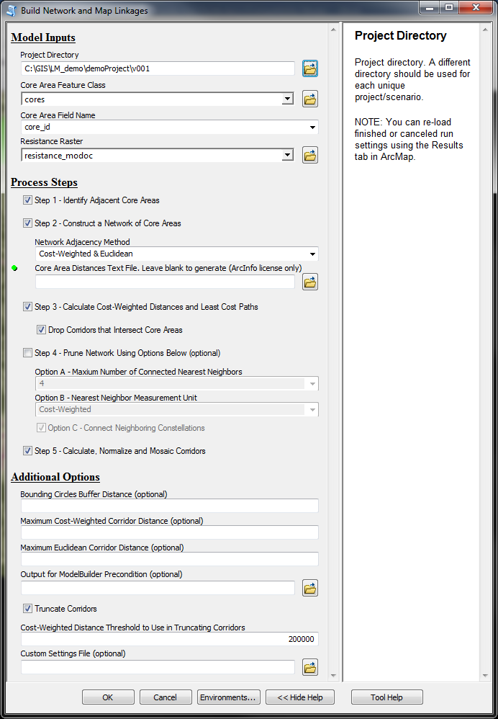

* Click **OK** to run the tool.
* Then, open the **Linkage Priority tool** in the Additional Tools toolset, point to the same inputs, and use the default settings:

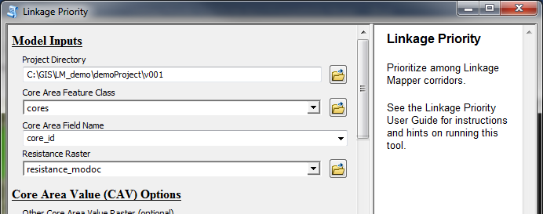

* Click **OK** to run the tool.
* After completion, add the dataset demoProject\v001\output\corridors.gdb\v001_linkage_priority to your map, and symbolize it with a Minimum-Maximum stretch. The output is referred to as the “Default Run” and should look something like the following:

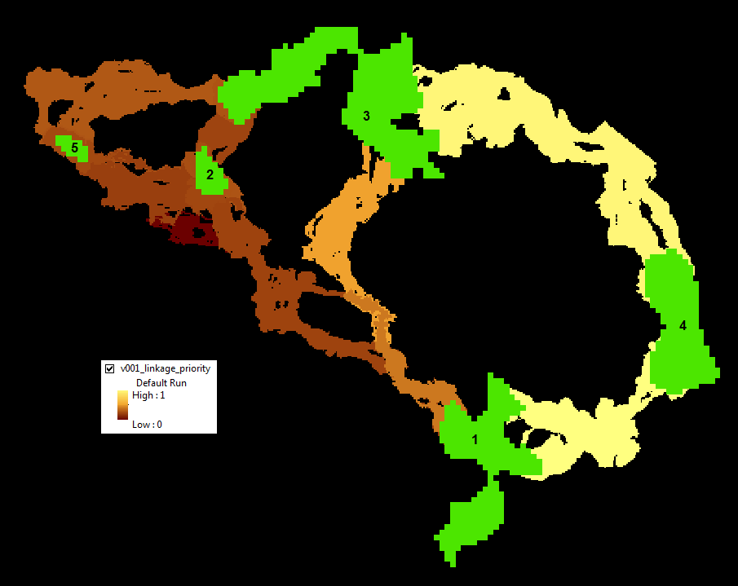

(Note, sometimes the low value is not exactly 0 due to a rounding error.)

LP also combines the linkage priority with the truncated cost output from the Build Network and Map Linkages tool in an evenly weighted sum, and calls it v001_blended_priority layer:

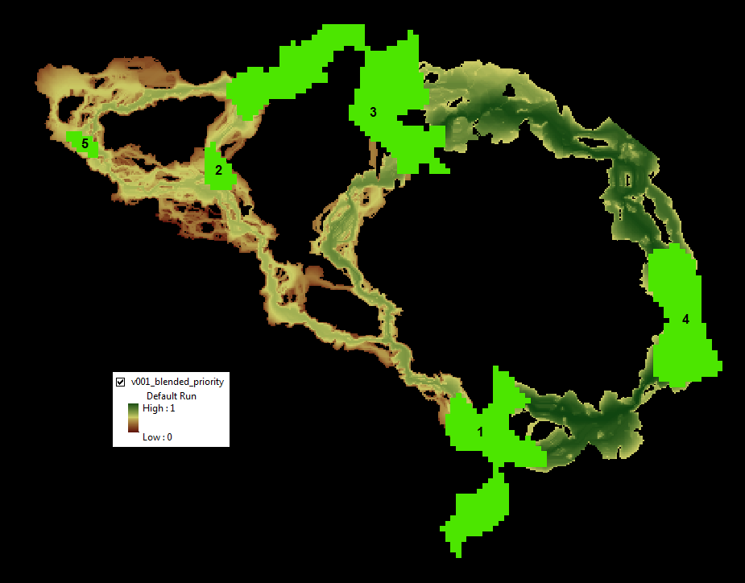

Note, you can change the weight in the Blended Priority Options:

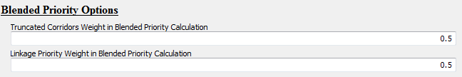

## Add Climate Refugia

In addition to the default considerations for Core Area Value, LP has an option to consider an additional raster input. This **Other Core Area Value** is averaged for each core area. It can be used for example, to give higher priority to corridors where the connected cores constitute important refugia areas. A dataset has been provided to demonstrate this capability, as follows:

* If you do not want to overwrite then make a new folder called v002 and run **Build Network and Map Linkages** tool again.
* Open the **Linkage Priority** tool. Provide the standard Model Inputs as above.
* Scroll down to the **Core Area Value (CAV) Options** and enter the following settings:

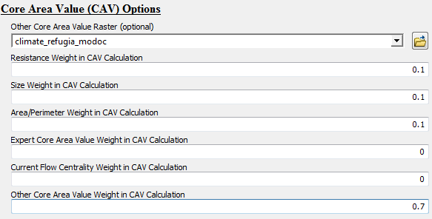

*Other Core Area Value Raster*: select climate_refugia_modoc

This dataset has higher values for areas of more stable climate and more topographic heterogeneity (from <https://databasin.org/datasets/d58de1a0b08443fea53c25b70804866c>) and is pre-loaded into the LP Demo .mxd. You can take a moment to examine the layer, and predict how it will change the results.

*Resistance Weight in CAV Calculation*: 0.1

*Size Weight in CAV Calculation*: 0.1

*Area/Perimeter Weight in CAV Calculation*: 0.1

*Other Core Area Value Weight in CAV Calculation*: 0.7

Note that much higher priority is given to the Other Core Area Value than to the other factors for illustration purposes.

* Leave all other settings at their defaults.
* Click **OK** to run the tool.
* Add the dataset demoProject\output\corridors.gdb\demoProject_linkage_priority to your map, and symbolize it with a Minimum-Maximum stretch. The output should look something like the following:

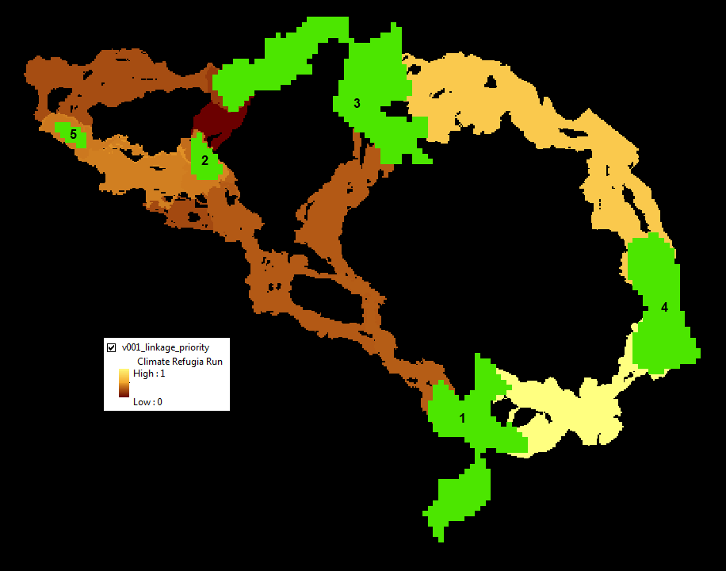

Note how the relative importance of linkages 2-5 and 1-4 are now higher. This is because cores 4,1, and 5 have more micro-refugia, and hence a higher average refugia score, than the other cores.

## Add Climate Signature

Another one of LP’s **optional features** for prioritizing corridors is **climate signature**. Two datasets have been provided to demonstrate this capability in the demo project, as follows:

* Open the **Linkage Priority** tool. Provide the standard Model Inputs as in Default Run, which means undoing the changes made for the Climate Refugia Run.
* Scroll down to the Corridor Specific Priority (CSP) Options and enter the following settings:

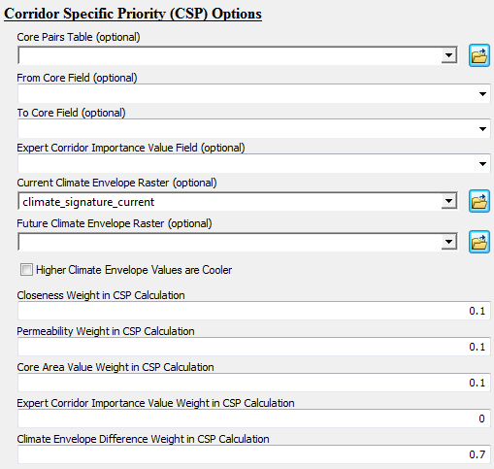

*Current Climate Envelope Raster*: select climate_signature_current

This dataset is the observed Climatic Water Deficit, where higher values are hotter/drier (from <https://databasin.org/datasets/dbd45814e4db43dea4472c3a3ccacd9b>).

*Closeness Weight in CSP Calculation*: 0.1

*Permeability Weight in CSP Calculation*: 0.1

*Core Area Value Weight in CSP Calculation*: 0.1

*Climate Envelope Difference Weight in CSP Calculation*: 0.7

Note that much higher priority is given to the Climate Envelope Difference than to the other factors. Climate envelope difference gives higher priority to corridors where the difference in climate envelope (i.e. climate signature) between the cores is high. This simulates cores where individuals of a species are able to move to “higher ground” and more suitable climate, over the decades.

* Leave all other settings at their defaults. Take a moment to look at the “climate_signature_current” layer in the table of contents. Note which core areas have a lower value (cooler and wetter).
* Click **OK** to run the tool.
* Add the dataset demoProject\output\corridors.gdb\demoProject_linkage_priority to your map, and symbolize it with a Minimum-Maximum stretch. The output should look something like the following:

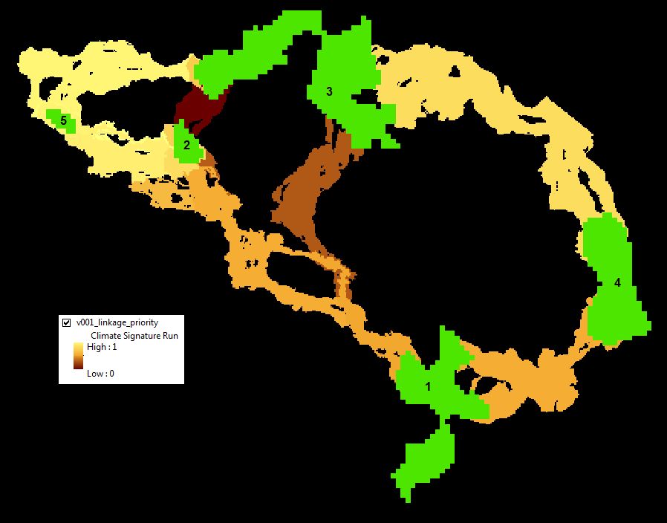

Compared to the earlier results, including climate envelopes in the prioritization increases the increases the relative priority of the corridors 2-5, 3-5 and 3-4, as all of these link a core with high climatic water deficit (hotter/drier) to one with lower CWD.

Note that a climate_signature_future layer has also been provided, and you are encouraged to run the climate signature scenario again with both the current and future layers, which will calculate the climate envelope difference of core pairs between the current situation and the future estimate.

Please refer to sections 4.3, 4.4 and 4.5 above for other optional inputs to corridor prioritization.

# Advanced Linkage Priority Tutorial

## Shortcut for Multiple Runs

In most projects it is useful to run multiple iterations of the model to explore different parameters, and values, and to compare their outputs. So far, each iteration has been overwriting outputs in the v001 folder. The following discusses how to make and store multiple runs, and how to run both **Build Network and Map Linkages** as well as **Linkage Priority** tools at the same time, which is especially useful for huge landscapes, and running both overnight. at the same time.

Click “Edit” on one of these tools:

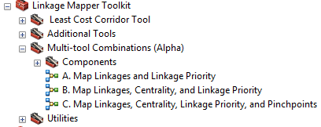

Change the “Project Directory” value to a new name. Run as much of the model as you can (the first step). Then validate the model. Then edit any parameter values as necessary. Save, and run the entire model.

## Add Centrality

Another one of LP’s **optional features** for prioritizing corridors is **core centrality**. This incorporates the outputs of Centrality Mapper as an input. See the Centrality Mapper user guide for more information on that tool. To use it here, run Centrality Mapper tool after running Build Network and Map Linkages, using the same Project Directory. Then, when using Linkage Priority, give Current Flow Centrality Weight in CAV Calculation a non-zero value, such as the following (remember, “best practice” is that all weights add to 1, so note that the Current Flow Centrality Weight has been adjusted):

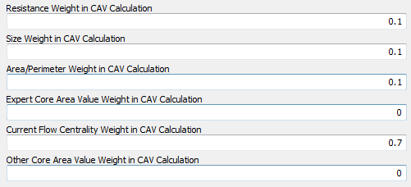

The result should look like the following:

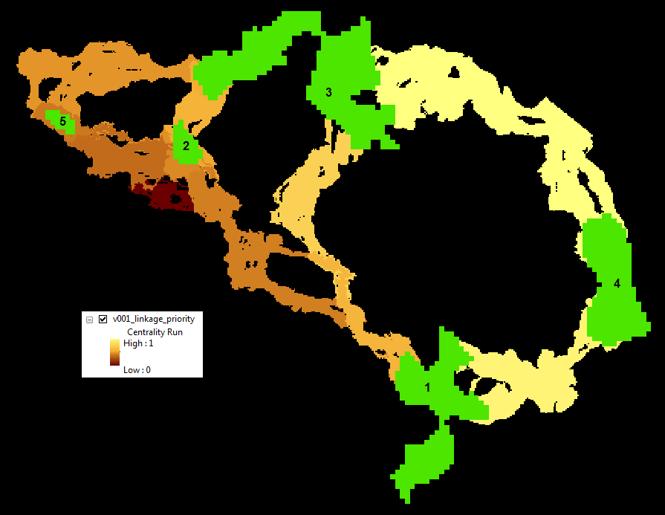

Note that Cores 2 and 3 are more cental than Cores 1, 4 and 5. Hence, linkages that involve these cores have a higher relative priority than they did on the initial run with default parameters. Note, the Centrality Mapper Tool iterates through all core pairs. Pinchpoint Mapper was written after Centrality Mapper, and gives an “all-to-one” option which is faster on large landscapes and very similar in output.

## Inspect Core Area Value Component Calculations

The components of core area value (see Geoprocessing Overview above) are all calculated in the input Core Area Feature Class attribute table, as follows:

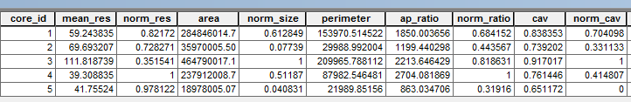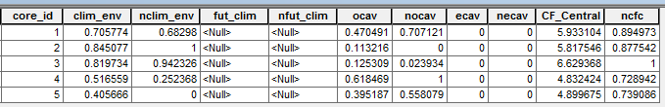

Note that the Expert Core Area Value (ecav) can be specified by editing this table. All other values will be overwritten on each run of LM/LP.

1. from Joe Fargione, Brad McRae's supervisor at The Nature Conservancy
2. This is because of the “carryover effect” that occurs in LP. This is most apparent when there is a really high priority linkage emanating from a core area, and also a low priority linkage from the same core area in a different direction. The high values of the high priority linkage carryover to the back side of the core area, essentially providing a small buffer. These then become a portion of the low priority linkage providing counter-intuitive results. Having the LP and LM linkage extents match (or LP being smaller) minimizes this effect.